Pin survey to home screen on Android

Pinning survey to a home screen on Android makes it available for quick entry. This is especially useful for survey that need to be filled in on a regular basis.
After opening the form, but before answering any questions:

Launch Chrome for Android and open the survey:

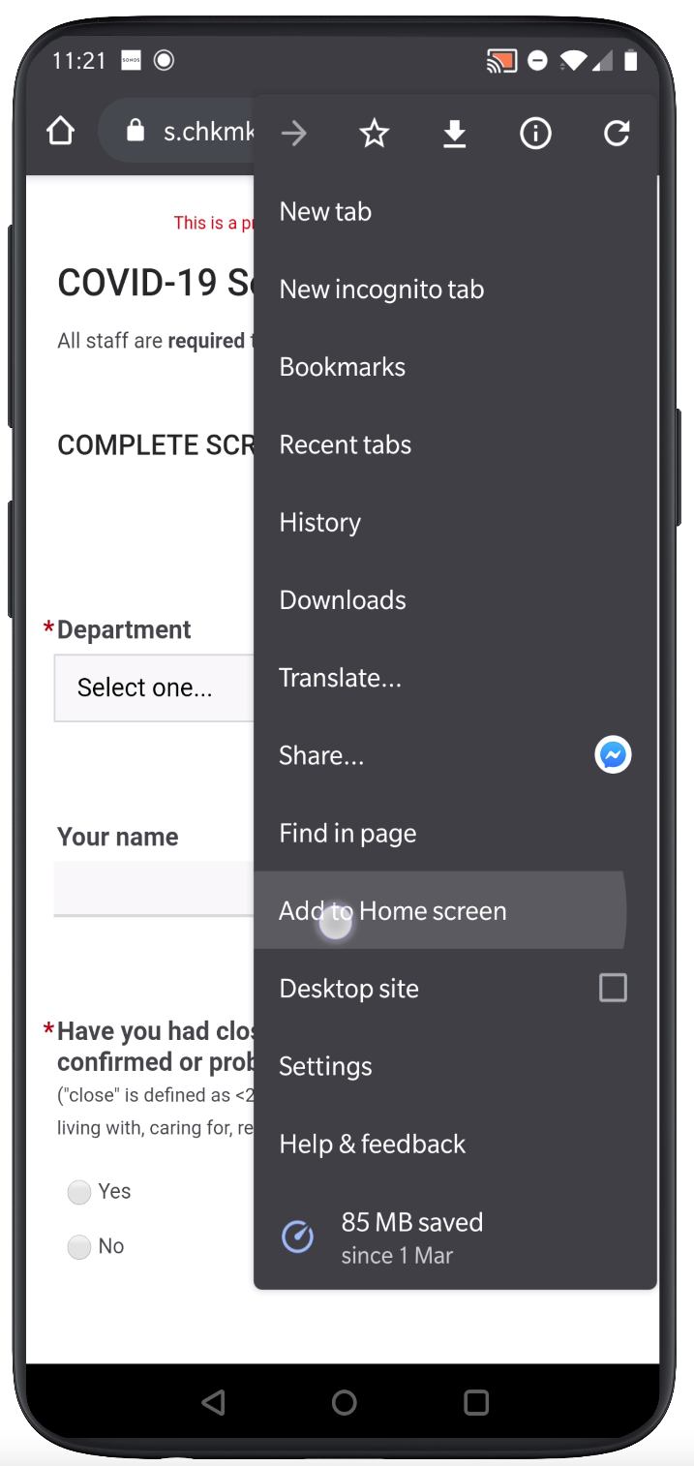 | 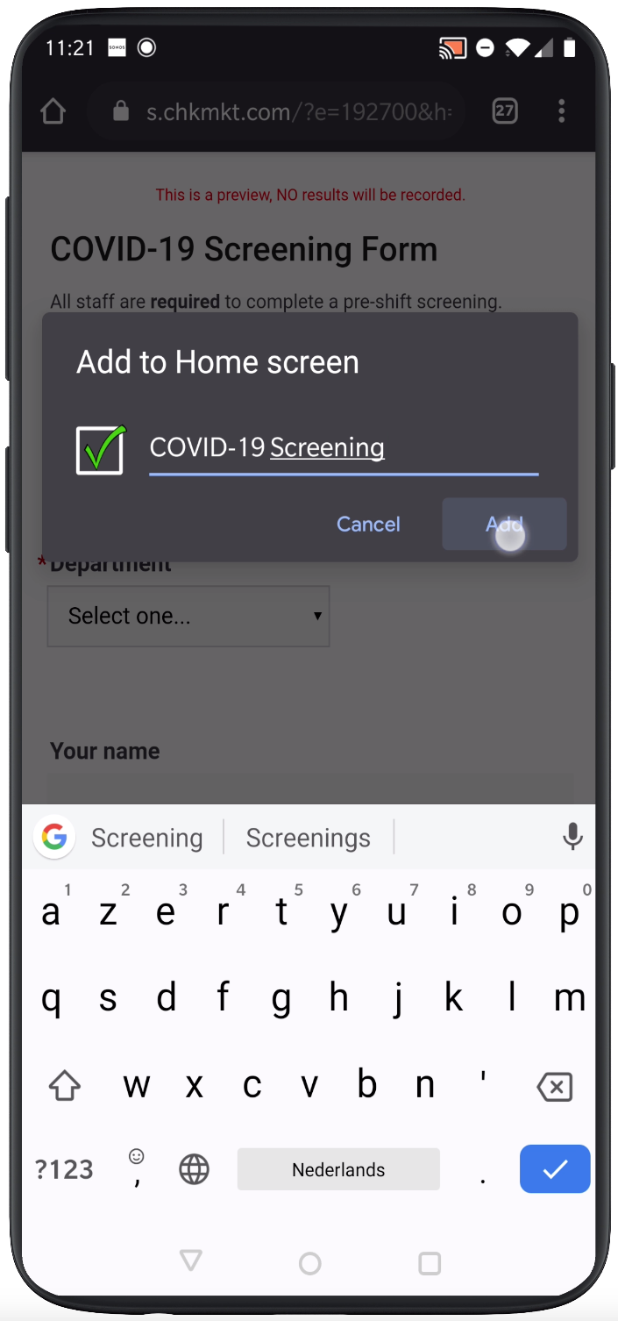 | 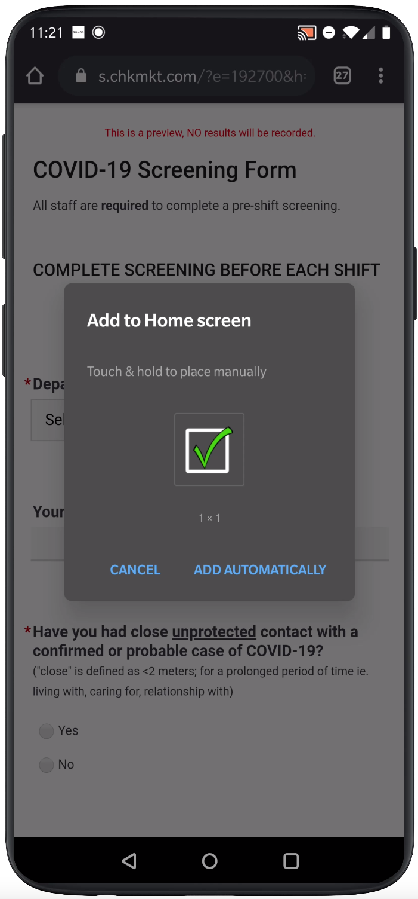 | 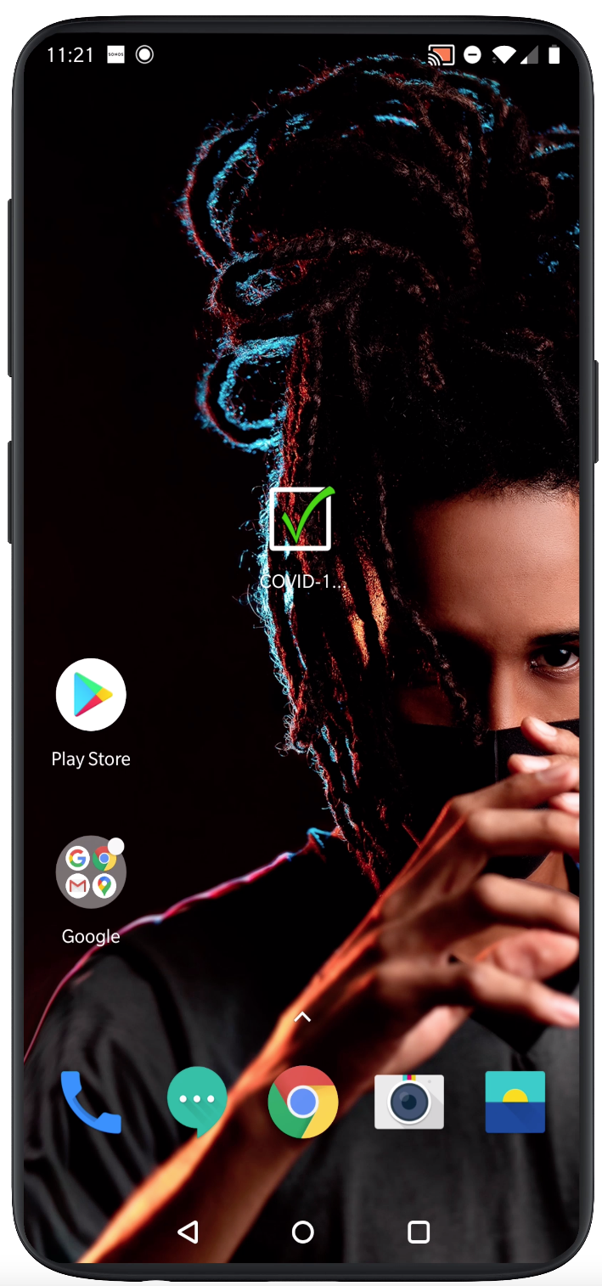
Before you start to the form, tap the menu button and tap ‘Add to home screen’. | Enter a name for the shortcut and click ‘Add’ | Click ‘Add automatically’ | Chrome will add it to your home screen.

