Pin survey to home screen on iOS

Pinning survey to a home screen on iOS and Android makes it available for quick entry. This is especially useful for survey that need to be filled in on a regular basis. After opening the form, but before answering any questions:

Open the survey in Safari:
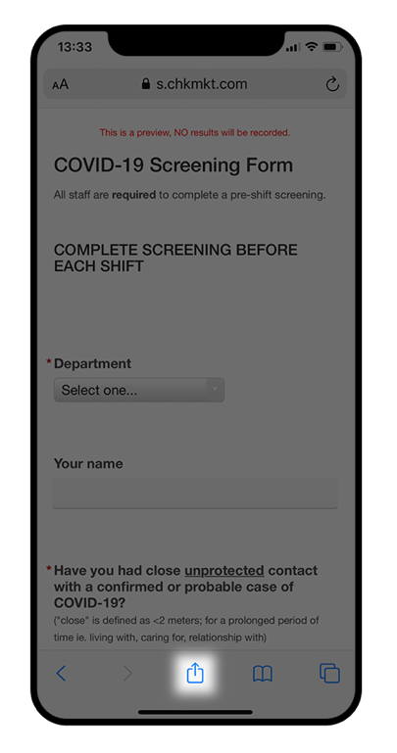 | 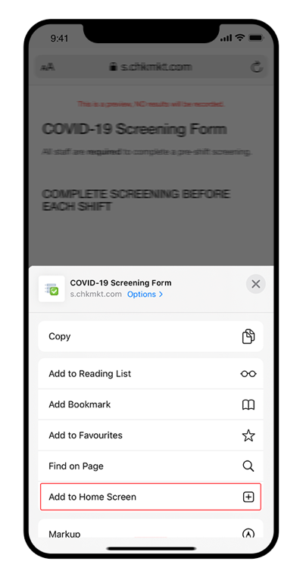 | 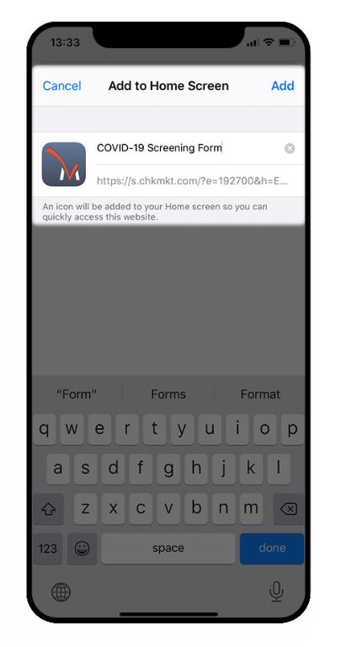 | 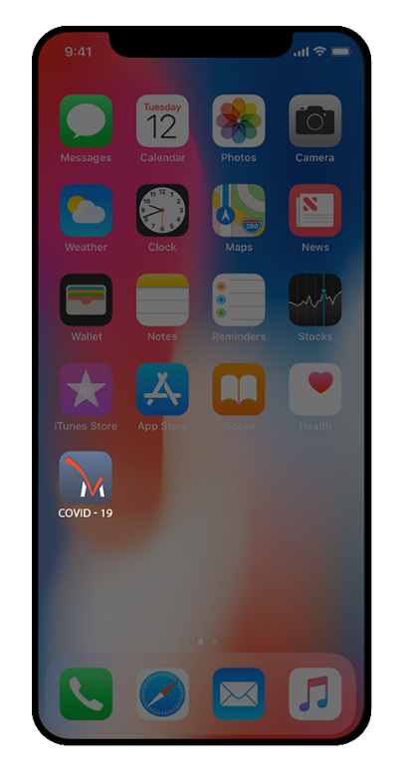
Before you start to the form, tap the share arrow. | Click the ‘Add to home screen’ button and tap it. | In this step, you can edit the name of the bookmark. Pick something short so you can see it all under the small icon label. | The survey is added to your  home screen.

